DBMS Lab File

Deepakshi Sharma

BCA AIML - 1B

### ****Question 1:****

### Create a table called Employee with the following structure:

Name | Type  
----------|-------  
Empno | Number  
Ename | Varchar2(20)  
Job | Varchar2(20)  
Mgr | Number  
Sal | Number

## SQL Code:

CREATE TABLE employee (  
 Empno NUMBER,  
 Ename VARCHAR2(20),  
 Job VARCHAR2(20),  
 Mgr NUMBER,  
 Sal NUMBER  
);  
  
-- Add a column commission to the employee table  
ALTER TABLE employee ADD commission NUMBER;  
  
-- Insert any five records  
INSERT INTO employee (Empno, Ename, Job, Mgr, Sal) VALUES (1, 'John', 'Manager', 2, 5000);  
INSERT INTO employee (Empno, Ename, Job, Mgr, Sal) VALUES (2, 'Lisa', 'Engineer', 1, 4000);  
INSERT INTO employee (Empno, Ename, Job, Mgr, Sal) VALUES (3, 'Mark', 'Technician', 2, 3500);  
INSERT INTO employee (Empno, Ename, Job, Mgr, Sal) VALUES (4, 'Anne', 'HR', 1, 3000);  
INSERT INTO employee (Empno, Ename, Job, Mgr, Sal) VALUES (5, 'Sam', 'Accountant', 4, 3200);  
  
-- Update the job of an employee  
UPDATE employee SET Job = 'Senior Manager' WHERE Empno = 1;  
  
-- Rename a column  
ALTER TABLE employee RENAME COLUMN Mgr TO Manager_ID;  
  
-- Delete employee whose Empno is 19 (as per instruction)  
DELETE FROM employee WHERE Empno = 19;

SELECT * FROM Employee;

## Output:

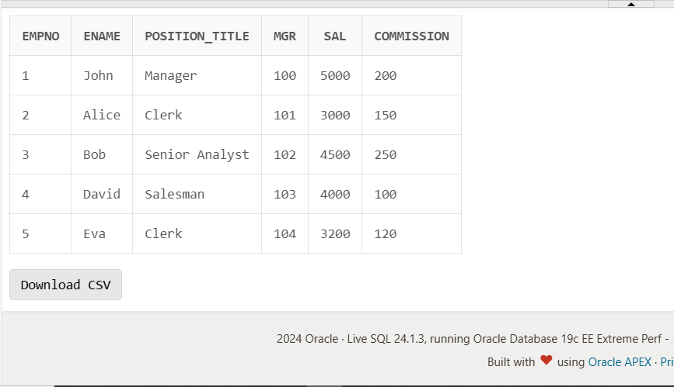

### ****Question 2:****

**Create a department table with the following structure:**

| **Name** | **Type** |
| --- | --- |
| Deptno | Number |
| Deptname | Varchar2(20) |
| Location | Varchar2(20) |

a. Add a column designation to the department table.  
b. Insert values into the table.  
c. List the records of emp table grouped by deptno.  
d. Update the record where deptno is 9.  
e. Delete any column data from the table.

## SQL Code:

-- a. Create the department table with the structure provided

CREATE TABLE Department (

deptno NUMBER,

deptname VARCHAR2(20),

location VARCHAR2(20)

);

-- b. Add a column 'designation' to the department table

ALTER TABLE Department

ADD designation VARCHAR2(20);

-- c. Insert values into the Department table

INSERT INTO Department (deptno, deptname, location, designation) VALUES (1, 'HR', 'New York', 'Manager');

INSERT INTO Department (deptno, deptname, location, designation) VALUES (2, 'Finance', 'London', 'Analyst');

INSERT INTO Department (deptno, deptname, location, designation) VALUES (3, 'Marketing', 'Berlin', 'Executive');

INSERT INTO Department (deptno, deptname, location, designation) VALUES (4, 'IT', 'San Francisco', 'Technician');

INSERT INTO Department (deptno, deptname, location, designation) VALUES (9, 'Sales', 'Tokyo', 'Salesperson');

-- d. Update the record where deptno is 9

UPDATE Department

SET location = 'Osaka'

WHERE deptno = 9;

-- e. Delete any column data from the table (Example: Remove designation from deptno 4)

UPDATE Department

SET designation = NULL

WHERE deptno = 4;

SELECT * FROM Department

## Output:

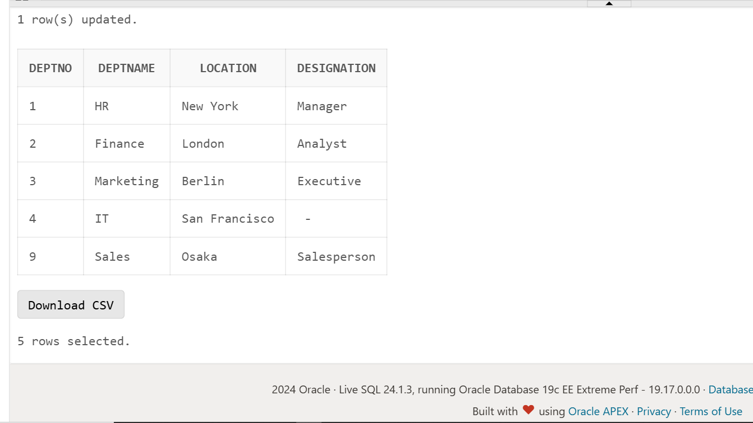

### ****Question 3:****

**Create a Sailor table with the following structure:**

| **Column** | **Type** |
| --- | --- |
| Sid | Number |
| Sname | Varchar2(20) |
| Rating | Number |
| Age | Number |

a. Insert 5 records into the Sailor table.  
b. List the details of sailors whose rating is greater than 8.  
c. Delete the record where age is greater than 35.  
d. Update the rating where Sid is 2.  
e. Display all the details from the Sailor table.

## SQL Code:

-- a. Create the Sailor table with the structure provided

CREATE TABLE Sailor (

Sid NUMBER,

Sname VARCHAR2(20),

Rating NUMBER,

Age NUMBER

);

-- b. Insert 5 records into the Sailor table

INSERT INTO Sailor (Sid, Sname, Rating, Age) VALUES (1, 'John', 9, 24);

INSERT INTO Sailor (Sid, Sname, Rating, Age) VALUES (2, 'Alice', 7, 29);

INSERT INTO Sailor (Sid, Sname, Rating, Age) VALUES (3, 'Bob', 8, 32);

INSERT INTO Sailor (Sid, Sname, Rating, Age) VALUES (4, 'David', 10, 40);

INSERT INTO Sailor (Sid, Sname, Rating, Age) VALUES (5, 'Eva', 6, 27);

-- c. List the details of sailors whose rating is greater than 8

SELECT * FROM Sailor

WHERE Rating > 8;

-- d. Delete the record where age is greater than 35

DELETE FROM Sailor

WHERE Age > 35;

-- e. Update the rating where Sid is 2

UPDATE Sailor

SET Rating = 8

WHERE Sid = 2;

-- f. Display all the details from the Sailor table

SELECT * FROM Sailor;

## Output:

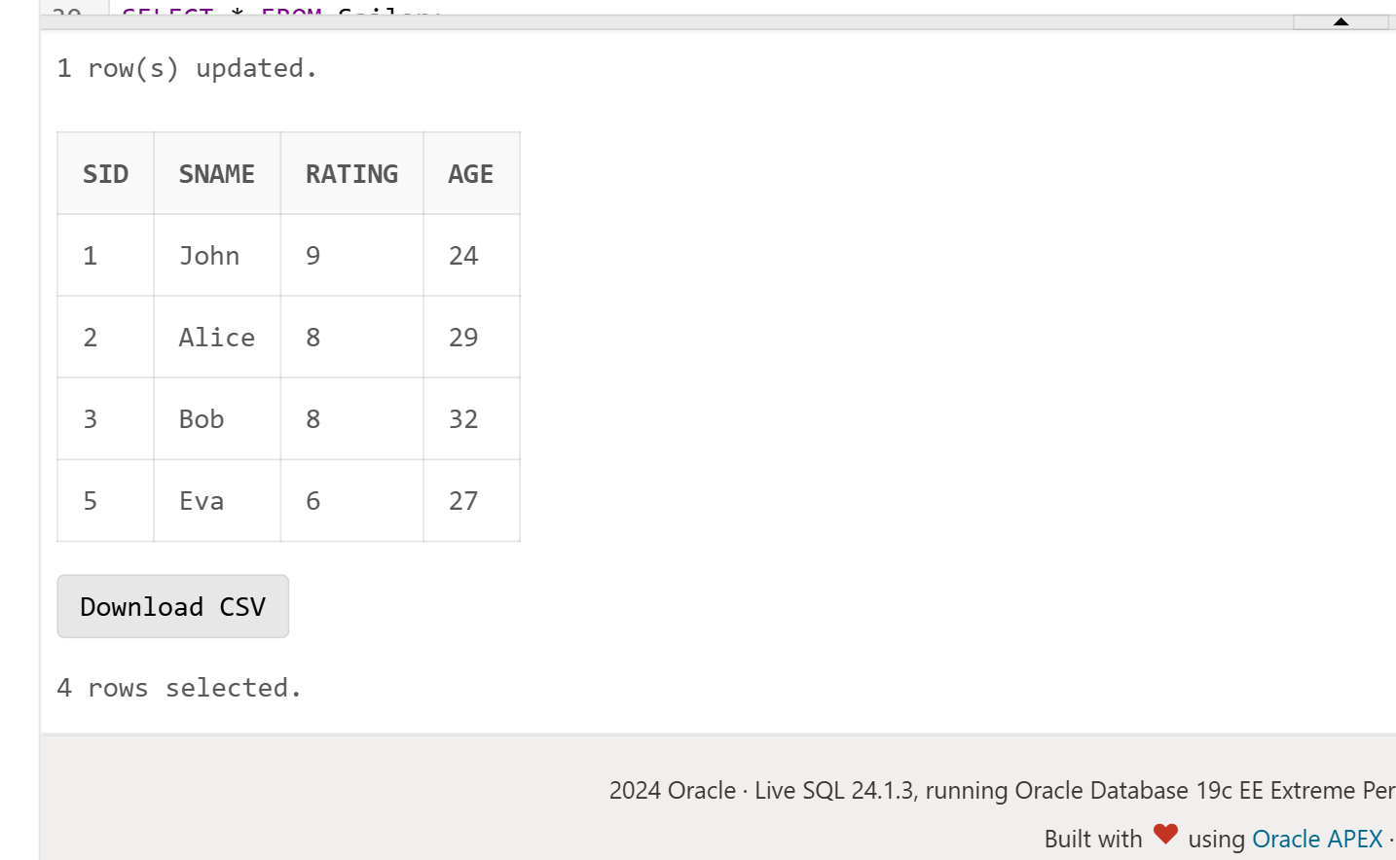

### ****Question 4:****

**Create a Reserves table with the following structure:**

| **Column** | **Type** |
| --- | --- |
| Sid | Number |
| BoatId | Number |
| Day | Date |

a. Insert any 4 records into the Reserves table.  
b. List the details of reservations made on '2024-10-01'.  
c. Update the BoatId for Sid 3.  
d. Delete the record where Sid is 2.  
e. Display all the details from the Reserves table.

## SQL Code:

-- a. Create the Reserves table with the structure provided

CREATE TABLE Reserves (

Sid NUMBER,

BoatId NUMBER,

Day DATE

);

-- b. Insert any 4 records into the Reserves table

INSERT INTO Reserves (Sid, BoatId, Day) VALUES (1, 101, TO_DATE('2024-10-01', 'YYYY-MM-DD'));

INSERT INTO Reserves (Sid, BoatId, Day) VALUES (2, 102, TO_DATE('2024-10-02', 'YYYY-MM-DD'));

INSERT INTO Reserves (Sid, BoatId, Day) VALUES (3, 103, TO_DATE('2024-10-03', 'YYYY-MM-DD'));

INSERT INTO Reserves (Sid, BoatId, Day) VALUES (4, 104, TO_DATE('2024-10-04', 'YYYY-MM-DD'));

-- c. List the details of reservations made on '2024-10-01'

SELECT * FROM Reserves

WHERE Day = TO_DATE('2024-10-01', 'YYYY-MM-DD');

-- d. Update the BoatId for Sid 3

UPDATE Reserves

SET BoatId = 105

WHERE Sid = 3;

-- e. Delete the record where Sid is 2

DELETE FROM Reserves

WHERE Sid = 2;

-- f. Display all the details from the Reserves table

SELECT * FROM Reserves;

## Output:

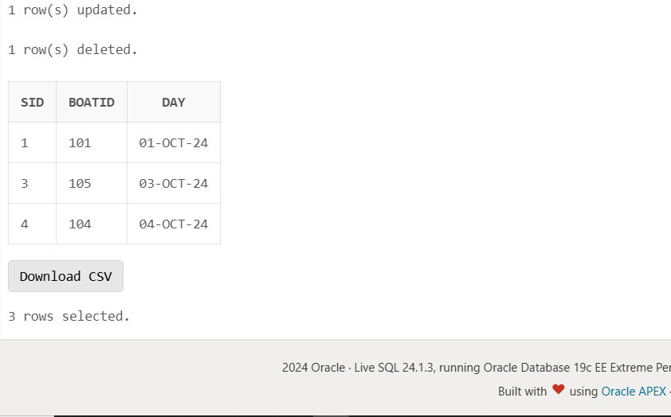

### ****Question 5:****

**Create a Boats table with the following structure:**

| **Column** | **Type** |
| --- | --- |
| BoatId | Number |
| Bname | Varchar2(20) |
| Color | Varchar2(10) |

a. Insert any 3 records into the Boats table.  
b. List the details of boats that are red in color.  
c. Update the boat name where BoatId is 2.  
d. Delete the record where BoatId is 3.  
e. Display all the details from the Boats table.

## SQL Code:

-- a. Create the Boats table with the structure provided

CREATE TABLE Boats (

BoatId NUMBER,

Bname VARCHAR2(20),

Color VARCHAR2(10)

);

-- b. Insert any 3 records into the Boats table

INSERT INTO Boats (BoatId, Bname, Color) VALUES (1, 'Sailor', 'Red');

INSERT INTO Boats (BoatId, Bname, Color) VALUES (2, 'Voyager', 'Blue');

INSERT INTO Boats (BoatId, Bname, Color) VALUES (3, 'Explorer', 'Red');

-- c. List the details of boats that are red in color

SELECT * FROM Boats

WHERE Color = 'Red';

-- d. Update the boat name where BoatId is 2

UPDATE Boats

SET Bname = 'Navigator'

WHERE BoatId = 2;

-- e. Delete the record where BoatId is 3

DELETE FROM Boats

WHERE BoatId = 3;

-- f. Display all the details from the Boats table

SELECT * FROM Boats;

## Output:

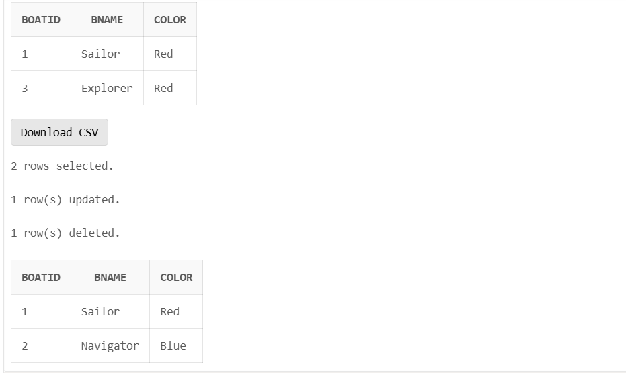

### ****Question 6:****

**Create a Suppliers table with the following structure:**

| **Column** | **Type** |
| --- | --- |
| SupplierId | Number |
| Sname | Varchar2(20) |
| City | Varchar2(20) |

a. Insert 4 records into the Suppliers table.  
b. List the suppliers who are from 'New York'.  
c. Update the city where SupplierId is 3.  
d. Delete the supplier with SupplierId 4.  
e. Display all the details from the Suppliers table.

## SQL Code:

-- a. Create the Suppliers table with the structure provided

CREATE TABLE Suppliers (

SupplierId NUMBER,

Sname VARCHAR2(20),

City VARCHAR2(20)

);

-- b. Insert 4 records into the Suppliers table

INSERT INTO Suppliers (SupplierId, Sname, City) VALUES (1, 'Supplier A', 'New York');

INSERT INTO Suppliers (SupplierId, Sname, City) VALUES (2, 'Supplier B', 'Los Angeles');

INSERT INTO Suppliers (SupplierId, Sname, City) VALUES (3, 'Supplier C', 'Chicago');

INSERT INTO Suppliers (SupplierId, Sname, City) VALUES (4, 'Supplier D', 'Houston');

-- c. List the suppliers who are from 'New York'

SELECT * FROM Suppliers

WHERE City = 'New York';

-- d. Update the city where SupplierId is 3

UPDATE Suppliers

SET City = 'San Francisco'

WHERE SupplierId = 3;

-- e. Delete the supplier with SupplierId 4

DELETE FROM Suppliers

WHERE SupplierId = 4;

-- f. Display all the details from the Suppliers table

SELECT * FROM Suppliers;

## Output:

